FSCT 8561 – Lab 0: Introduction to Network Protocols using Python Sockets
By: Jose Bangate, A01271709

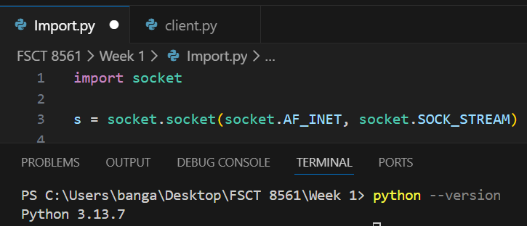
Task 1: Environment Verification

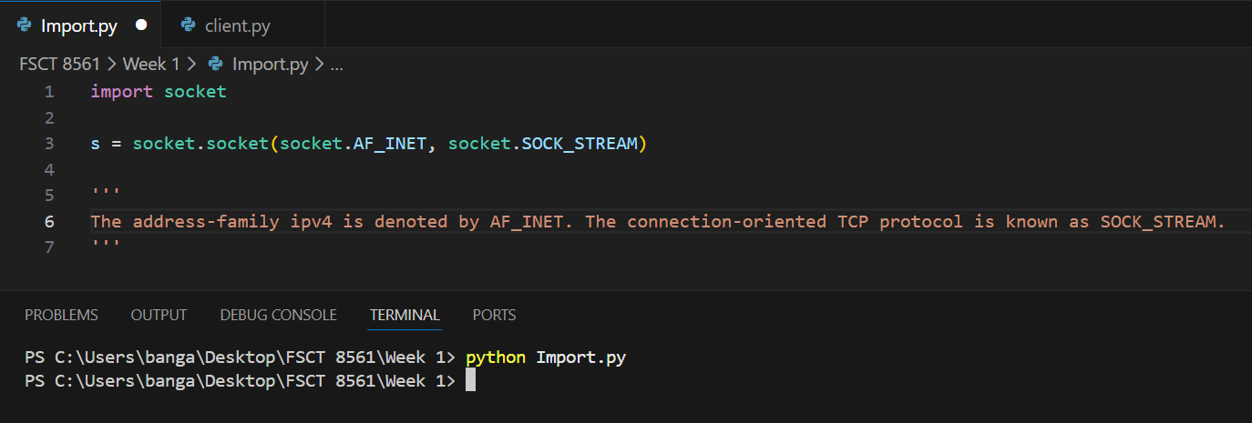
Task 2: Understanding Sockets

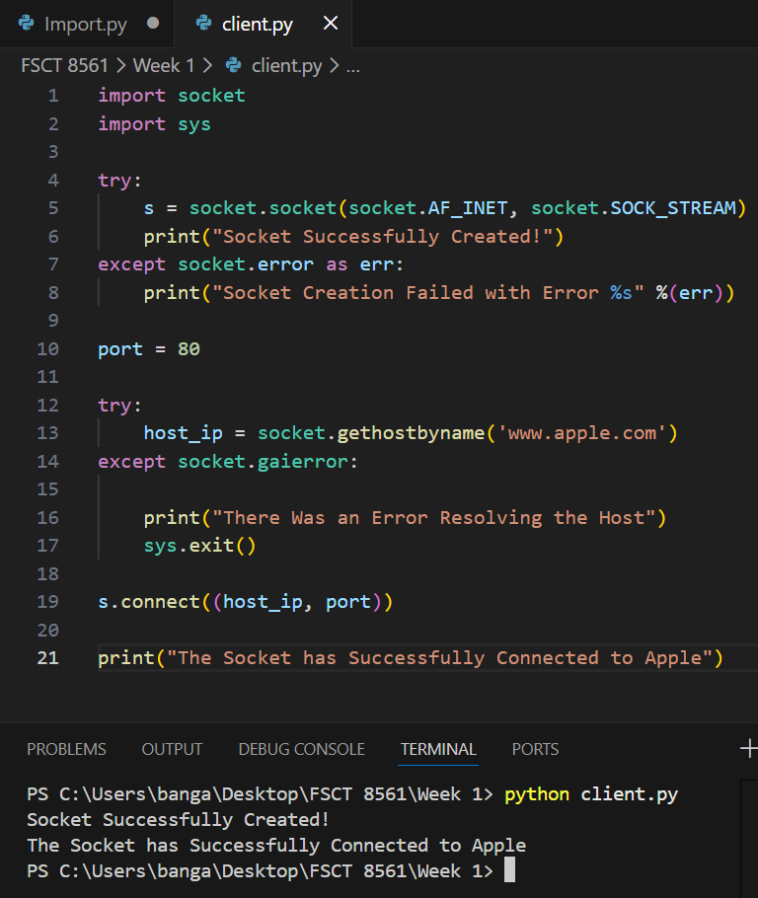
Task 3: Simple Client Connection

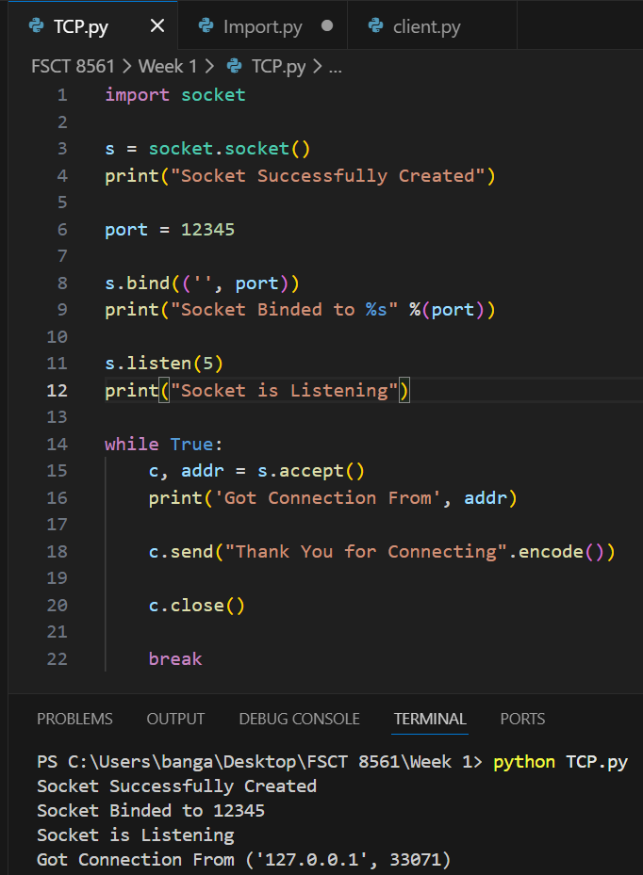
Task 4: Create a TCP Server:

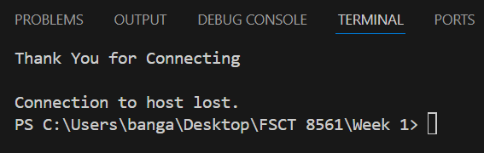
Task 5: Create a TCP Client
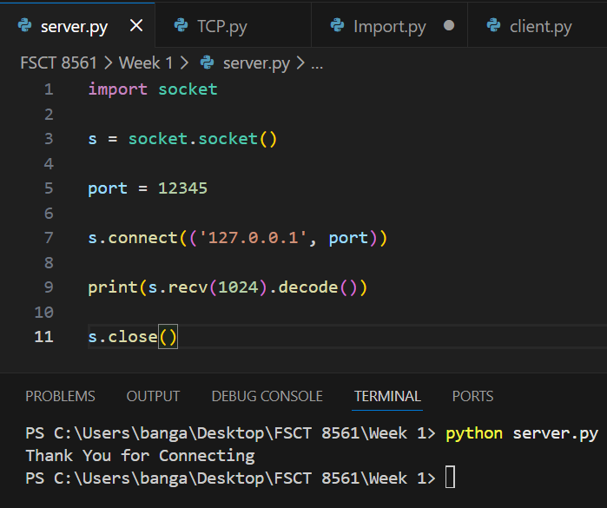

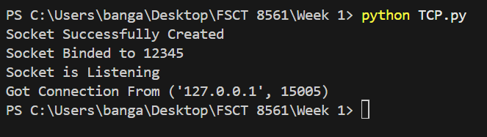

Task 6: Security Reflection
- Three Security Risks
- Sensitive Data Exposure: Programs that use raw sockets have access to all incoming packets, not just their own, which raises the possibility of inadvertently logging or exposing other traffic, which could result in the leakage of network data from other programs.
- Privilege Escalation & Misuse: To generate raw sockets on most systems, you need administrator or root rights. The impact of vulnerability or exploits is increased when code is executed with higher privileges, giving attackers more control.
- Packet Spoofing & Injection Risk: Attackers can utilize raw sockets to create arbitrary packets, including ones with fake source addresses, for denial-of-service, man-in-the-middle, and session hijacking attacks.
- Input Validation, Access Control, and Protocol Awareness
  - By preventing malicious or corrupted data from being processed or sent, input validation helps prevent attacks like buffer overflow and protocol misuse that could compromise systems or crash services. Only well-formed packets or parameters are accepted when network inputs are validated.
  - Access control makes sure that resources on a network can only by accessed or communicated with by authorized users, devices, or services. Robust access control restricts unwanted access and lowers the possibility of breaches and attackers’ lateral movement.
  - Understanding and upholding the anticipated behaviour of network protocols is known as protocol awareness. It lowers the possibility of protocol abuse, data damage, or security flaws brought on by erroneous messages by assisting systems in identifying and rejecting unexpected or non-compliant traffic.
- Secure your Simple Client-server Application
  - Using Encryption (TLS/SSL): To prevent eavesdropping and manipulation of data in transit, encrypt all network traffic using TLS (e.g., via ssl modules or frameworks that enable HTTPS).

